The University of Texas at Dallas

Database Design – Prof. Nurcan, Yuruk

**Assignment 01**

**1.** Museum Application -

**Assumptions**:

1. BORROWED COLLECTION are bought from COLLECTION.
2. SCULPTURE contains information of both Sculptures and Statues (as thet dont have any distinguishing attribute).
3. Each ART OBJECT is made by a single ARTIST. Or simply, artists won't work together on the same art object.
4. Included two attributes in ART OBJECTS – Object Type and Collection Type to state the type of art object accordingly.
5. Included Object Style as an attribute too, in order to mention style of each object type (as it was a common attribute of all sub-classes in Object type specialization).
6. Underlined attributes are assumed to be unique, if not mentioned in the problem.

**EER**:

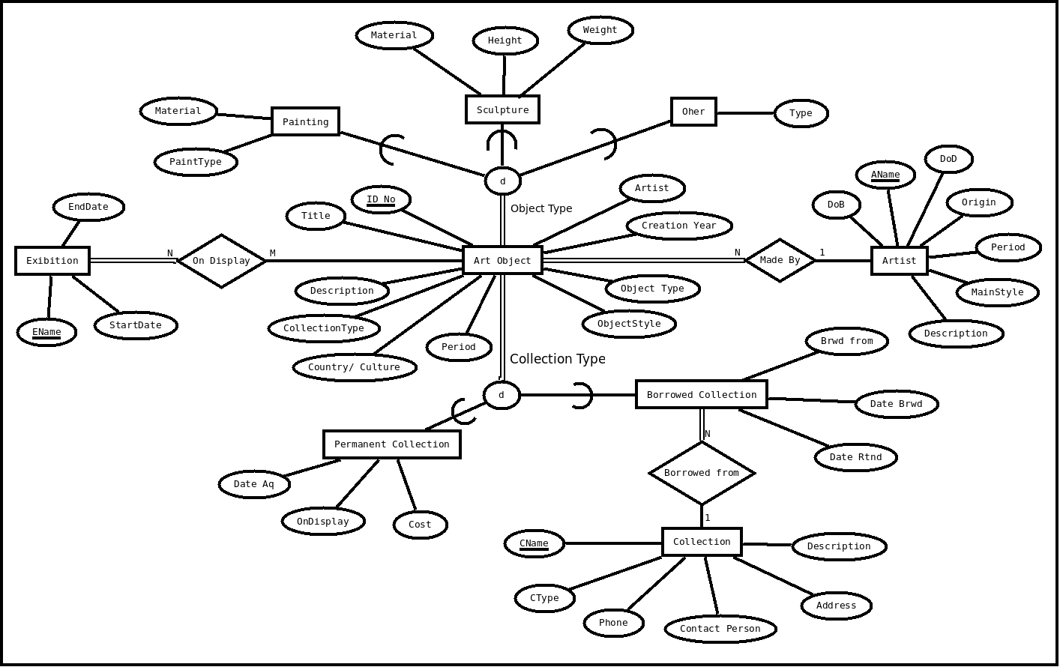

**2.** EER for an Investment Company -

**Assumptions**:

1. At the time of purchase from a customer account, one would buy according to the lots available of a particular stock.
2. So, Lot is assumed to be the weak entity with an identifying relation to the Stock Holding.
3. Quantity for Stock Holding entity is an derived attribute from the LotQuantity of Lot entity.
4. Purchase Date is a partial key for Lot entity.
5. IsEmployee is a boolean type attribute for stating a person as an employee or else.
6. There is exactly one Manager for a Branch.
7. Underlined attributes are assumed to be unique, if not mentioned in the problem.

**EER**:

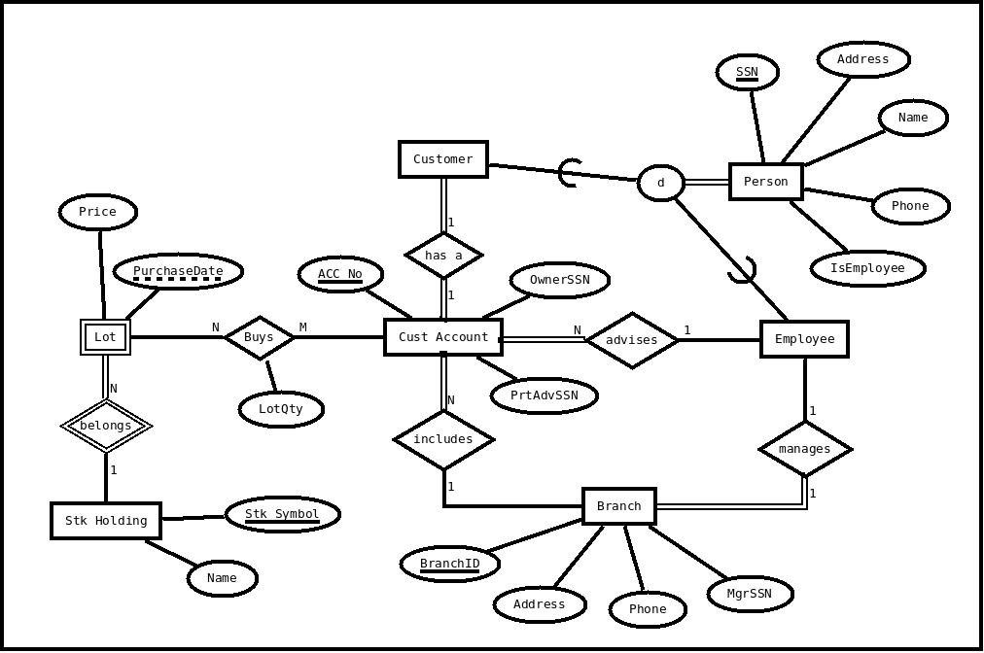

**3.** Relational model for problem 2.

**Relational Schema:**

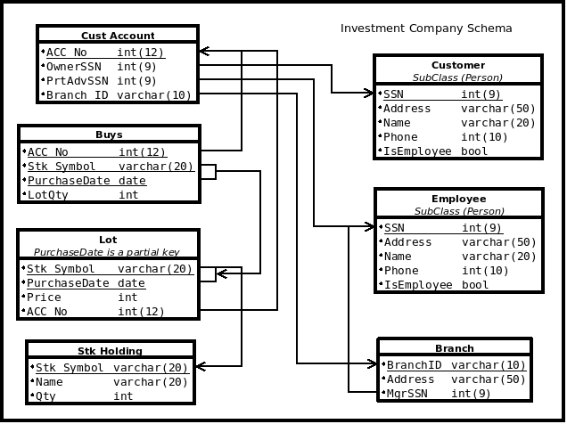

**Assumptions**:

1. Person to Customer or Employee specialization is modeled as 8B, as it is a total participating specialization.
2. Partial key of Table Lot is mentioned as a <bold> attribute.
3. Qty is derived from LotQty and is shown by a dotted arrow.

**4.** Ralational database schema:

**Assumptions:** 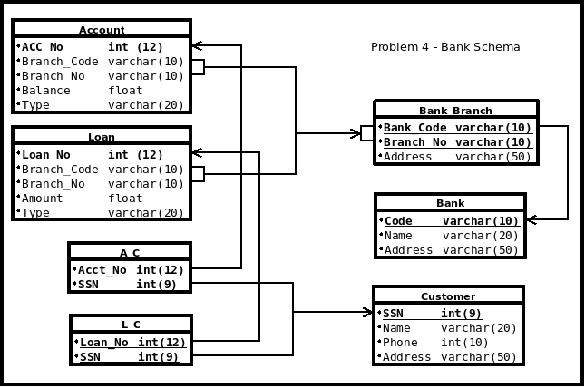

1. <bold> & <underline> attributes are primary key of the the relations.
2. All the arrows show a foreign key reference.
3. A_C and L_C has SSN as it's one of the component of Primary Key (may not be clearly visible).

**5.** Relational Schema design for 4 options -

**1. 8A Design:**

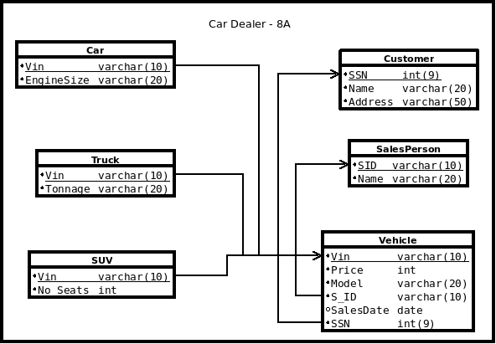

**2. 8B Design:**

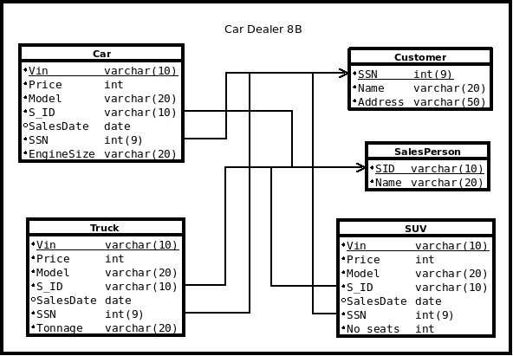

**3. 8C Design:**

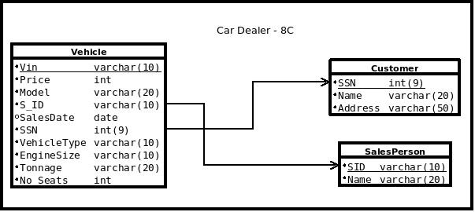

**4. 8D Design:**

